# Bachelor/Master Thesis – Research plan

Title

Student:

Supervisor(s):

Starting date:

End date:

Work load: [1 ECTS = 25-30h, e.g. 30 ECTS = 750-900 h]

# A Introduction

Short paragraph to introduce the topic, e.g. context, problem statement, state-of-the-art…

# B State of the Art

Short literature review of the most important research in the field. Build on it and state your hypothesis.

# C Goals

**D Methodology**

E.g.: Techno-economic analysis with four scenarios of changing prices (explain briefly)…

Include tables/schematics if relevant.

## E Timeline

The various tasks over the course of 6 months (24 weeks) will be:

1. Literature Review
2. Data Collection
3. Modelling
4. Analysis, model runs
5. Results interpretation and discussion.
6. Report preparation and presentation.

Please refer Table 1 for the Timeline.

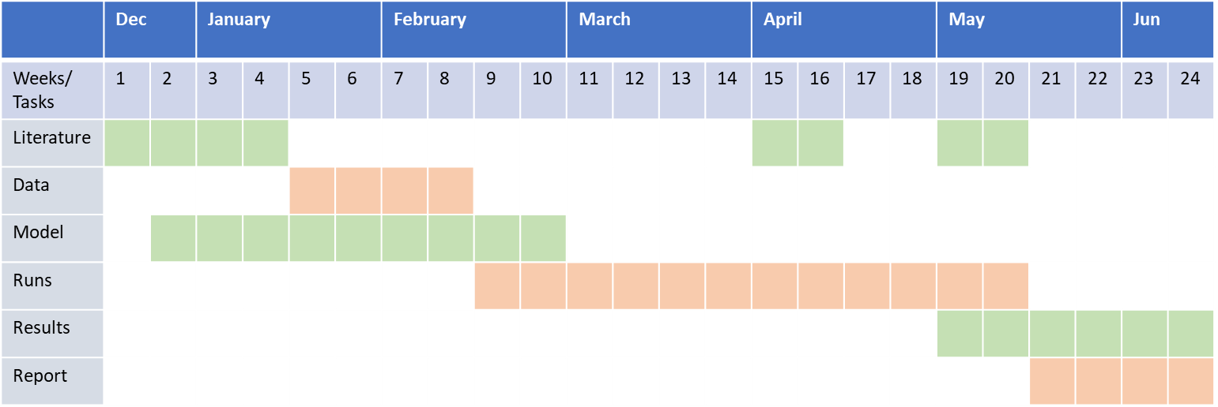

Table 1: Timeline

# F Contribution

Potential results of your work/novelty.

# G References

[Note: We recommend choosing a citation style like APA or Harvard, but consistency is most important.]

[1] Luthander, R., Widén, J., Nilsson, D., & Palm, J. (2015). Photovoltaic self-consumption in buildings: A review. In Applied Energy (Vol. 142, pp. 80–94). Elsevier Ltd. https://doi.org/10.1016/j.apenergy.2014.12.028

# H Planned Deliverables

**Mid-term presentation:** Roughly 3 months in [enter approx. date]. At the middle of the project, the work will be presented to the supervisors and interested persons for feedback.

**Draft report:** Month 6. 1 week prior to the final presentation a pdf of the draft report will be sent to the supervisors.

**Final presentation:** Month 6. At the end of the project, the work will be presented to the chair during a group meeting or equivalent.

**Final report:** Month 6. Final report (PDF, hard copy, simulation files, …) is due on/before the end date.