Bachelor / Master Thesis – Research plan

Title
Student:
Supervisor(s):
Planned registration date:
Planned submission date:
Workload: [Please adjust this number according to your study program’s ECTS-requirement:
1 ECTS = 25-30h, e.g. 30 ECTS = 750-900 h]

A Introduction
Short paragraph to introduce the topic, e.g., context, problem statement and why it is worth dealing with.

B State of the Art
Short literature review of the most important research in the field. Build on it and state your research question(s) and (if applicable) derive hypotheses.

C Goals of the thesis
What do you want to achieve in writing this thesis (strongly depends on the research question): creating an overview of current literature, show an effect in a certain population, learn more of drivers and barriers of a certain phenomenon, …
D Methodology
Choose methodology appropriate to answer research question, e.g., systematic literature review, system implementation, quantitative survey, techno-economic analysis, requirements analysis according to design theory, qualitative expert interviews, …
State why your chosen method is the best option to achieve your stated goals.

E Proposed thesis structure
Create a draft for a table of contents of your thesis. Refer to appropriate sources or your supervisor if you are not sure how to structure it. It does not need to be final but should represent a mature draft that you will be able to roughly adhere to when going about writing your thesis.
Where possible, fill in “empty” words (e.g., “Methodology” = “Literature Search Approach” or “Experimental Procedure”, etc.)
- Introduction
- Related Work
- Methodology
- Results
- Discussion

F Timeline
The various tasks over the course of the duration of your thesis (different per study program) will be (example):
- Literature Review
- Data Collection
- Analysis
- Results interpretation and discussion

A tabular timeline is an option. This is an exercise for you to consider the necessary steps and align expectations on necessary efforts with your supervisor.
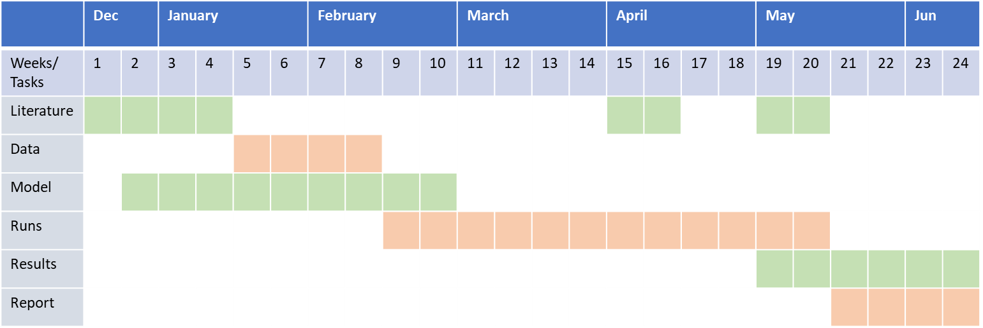
Table 1: Timeline

G Contribution
Potential results of your work/novelty.

H References
[Important: agree on or choose a citation style and stick to it.]
[1] Luthander, R., Widén, J., Nilsson, D., & Palm, J. (2015). Photovoltaic self-consumption in buildings: A review. In Applied Energy (Vol. 142, pp. 80–94). Elsevier Ltd. https://doi.org/10.1016/j.apenergy.2014.12.028

